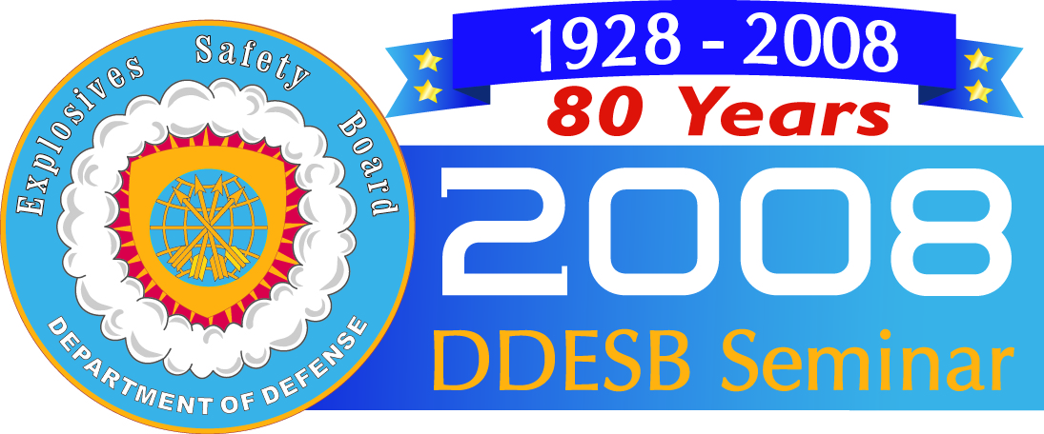

2008 DDESB Seminar
Seminar Proceedings Order Form
August 12-14, 2008
Hyatt Grand Champions Resort, Villas and Spa
Palm Springs, CA

Please complete this form in order to purchase the 2 GB flash drive with seminar proceedings. Submit by mail, e-mail, or fax
with payment information to:

Impact Associates, Inc. Phone: 865.379.7065
2734 East Broadway Avenue Fax: 865.379.7094
Maryville, TN 37804 USA E-mail: service@ddesbseminar.org

Contact Information (please print): Mr. Ms. Mrs. Dr. Military Rank:

First Name: Last Name:

Company/Organization Name: Job Title:
Branch of Service (if applicable):
Organization Type (check all that apply):
Federal Government State Government City/County Government Academia Industry Foreign
Mailing Address: City: State:
Postal Code: Country:
Telephone: Fax: E-mail Address:

Seminar Proceedings will not be mailed until full payment is received (US Dollars).

 | Cost
US Citizen | $50
Non-US Citizen | $100

Payment Information (US Dollars):
Money Order
Check No.: Dated: Tax ID No.:
VISA MasterCard American Express

Card No.: Expiration Date: 3-4 digit Security Code:
Name on Card: Signature:
Billing Address for Credit Card: Street City
State Zip Code

Please make checks drawn on US banks payable to Impact Associates, Inc.

